Jeremy Scheuerman

Dr. Wang

Lab 6.1

6.1

1.

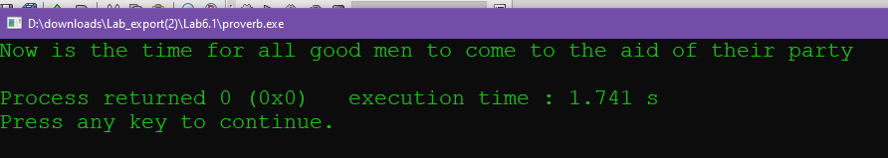

Source Code

// This program prints the proverb

// "Now is the time for all good men to come to the aid of their party"

// in a function (procedure) called writeProverb that is called by the main function

// PLACE YOUR NAME HERE

#include <iostream>

using namespace std;

void writeProverb(){

cout<<"Now is the time for all good men to come to the aid of their party"<<endl;

} // This is the prototype for the writeProverb function

int main()

{

writeProverb();

return 0;

}

//*********************************************************************

// writeProverb

//

// task: This function prints a proverb

// data in: none

// data out: no actual parameter altered

//

//********************************************************************

// Fill in the function heading and the body of the function that will print

// to the screen the proverb listed in the comments at the beginning of the

// program

6.2

1 . 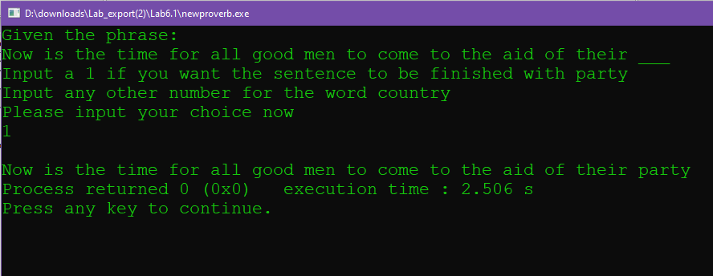

When this is entered it just acts as another number that is not 1

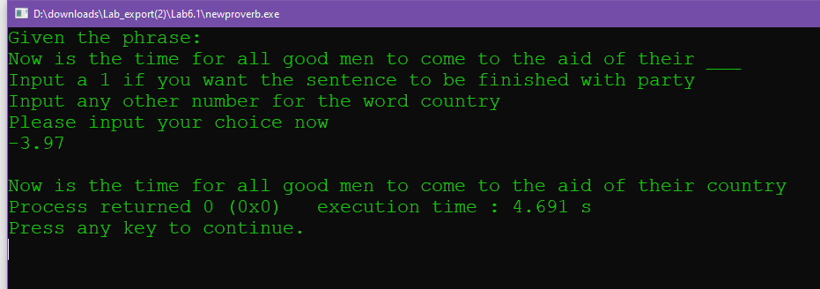

2. 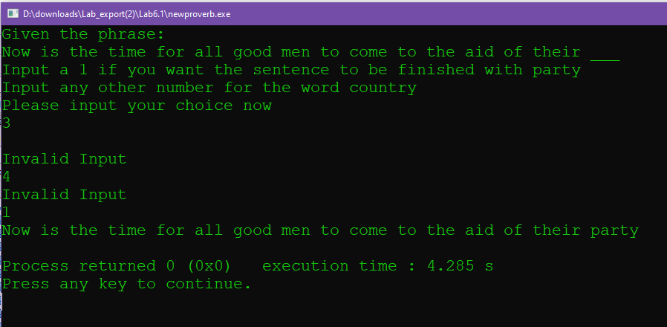

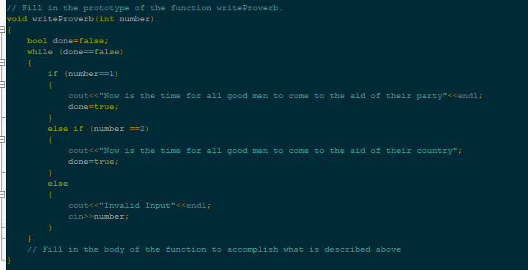

3. 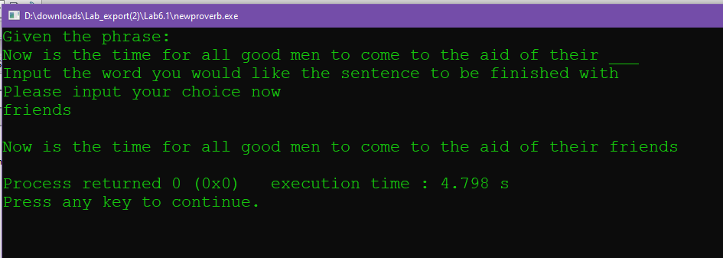

// This program will allow the user to input from the keyboard

// whether the last word to the following proverb should be party or country:

// "Now is the time for all good men to come to the aid of their ___"

// Inputting a 1 will use the word party. Any other number will use the word country.

// PLACE YOUR NAME HERE

#include <iostream>

#include <string>

using namespace std;

// Fill in the prototype of the function writeProverb.

void writeProverb(string word)

{

cout<<"Now is the time for all good men to come to the aid of their "<<word<<endl;

}

int main()

{

string wordCode;

cout << "Given the phrase:" << endl;

cout << "Now is the time for all good men to come to the aid of their ___"

<< endl;

cout << "Input the word you would like the sentence to be finished with"

<< endl;

cout << "Please input your choice now" << endl;

cin >> wordCode;

cout << endl;

writeProverb(wordCode);

return 0;

}

// ******************************************************************************

// writeProverb

//

// task: This function prints a proverb. The function takes a number

// from the call. If that number is a 1 it prints "Now is the time

// for all good men to come to the aid of their party."

// Otherwise, it prints "Now is the time for all good men

// to come to the aid of their country."

// data in: code for ending word of proverb (integer)

// data out: no actual parameter altered

//

// *****************************************************************************

6.3

1

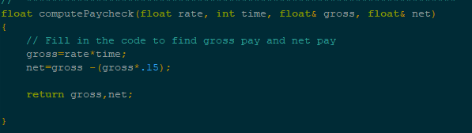

2

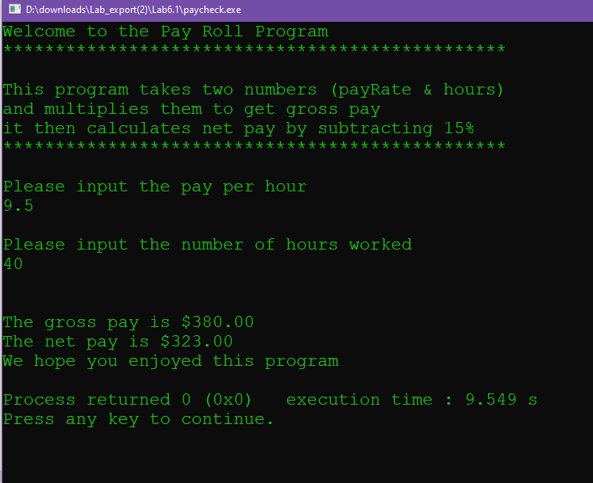

3 It is a pass by value

4

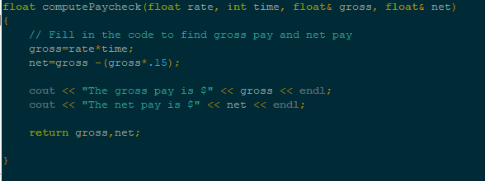

5

All values are the same

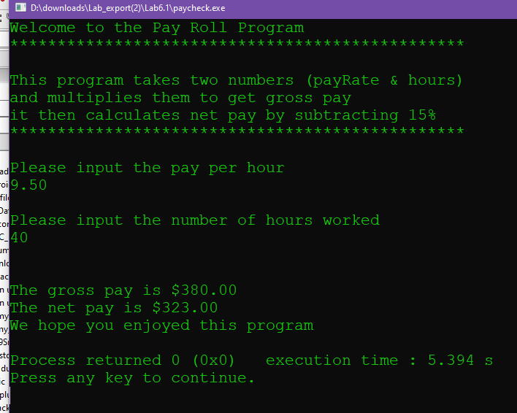

Source code

// This program takes two numbers (payRate & hours)

// and multiplies them to get grosspay.

// It then calculates net pay by subtracting 15%

// PLACE YOUR NAME HERE

#include <iostream>

#include <iomanip>

using namespace std;

// Function prototypes

void printDescription();

float computePaycheck(float, int, float&, float&);

int main()

{

float payRate;

float grossPay;

float netPay;

int hours;

cout << setprecision(2) << fixed;

cout << "Welcome to the Pay Roll Program" << endl;

printDescription(); // Call to Description function

cout << "Please input the pay per hour" << endl;

cin >> payRate;

cout << endl << "Please input the number of hours worked" << endl;

cin >> hours;

cout << endl << endl;

computePaycheck(payRate, hours, grossPay, netPay);

// Fill in the code to output grossPay

cout << "We hope you enjoyed this program" << endl;

return 0;

}

// ********************************************************************

// printDescription

//

// task: This function prints a program description

// data in: none

// data out: no actual parameter altered

//

// ********************************************************************

void printDescription() // The function heading

{

cout << "************************************************" << endl << endl;

cout << "This program takes two numbers (payRate & hours)" << endl;

cout << "and multiplies them to get gross pay " << endl;

cout << "it then calculates net pay by subtracting 15%" << endl;

cout << "************************************************" << endl << endl;

}

// *********************************************************************

// computePaycheck

//

// task: This function takes rate and time and multiples them to

// get gross pay and then finds net pay by subtracting 15%.

// data in: pay rate and time in hours worked

// data out: the gross and net pay

//

// ********************************************************************

float computePaycheck(float rate, int time, float& gross, float& net)

{

// Fill in the code to find gross pay and net pay

gross=rate*time;

net=gross -(gross*.15);

cout << "The gross pay is $" << gross << endl;

cout << "The net pay is $" << net << endl;

return gross,net;

}

6.4 Optional 1

1/2

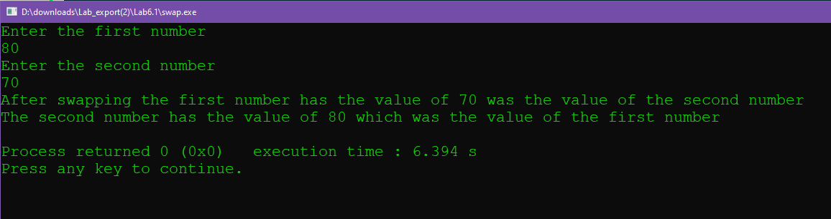

3

The swap parameters must be passed by value

Source Code

#include <iostream>

using namespace std;

void swap(float num_1,float num_2)

{

float temp=num_1;

num_1=num_2;

num_2=temp;

//do the swap

cout<<"After swapping the first number has the value of "<<num_1<<" was the value of the second number"<<endl;

cout<<"The second number has the value of "<<num_2<<" which was the value of the first number"<<endl;

}

int main()

{

float num_1;

float num_2;

cout<<"Enter the first number"<<endl;

cin >>num_1;

cout<<"Enter the second number"<<endl;

cin >>num_2;

swap(num_1,num_2);

//swap them

return 0;

}